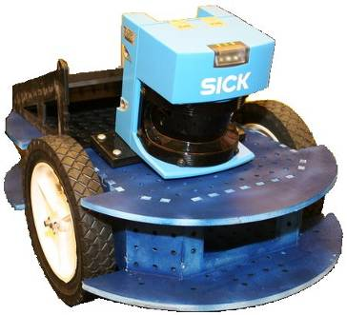 | New Fall 2005 Mobile Robotics Subject  6.189J / 2.994J / 16.402J  Robotics: Science and Systems II  http://courses.csail.mit.edu/6.189/
- Want to build robots that autonomously navigate and manipulate objects in outdoor terrain?
- Want to take part in a novel lab course that spans EECS, MechE and Aero/Astro?
- Are you a junior/senior with some robotics experience (6.188, 2.12, MASLab, or equivalent)?

With state of the art equipment, explore topics like navigation, vision, localization, and kinematics to tackle a tough mobile robotics problem.

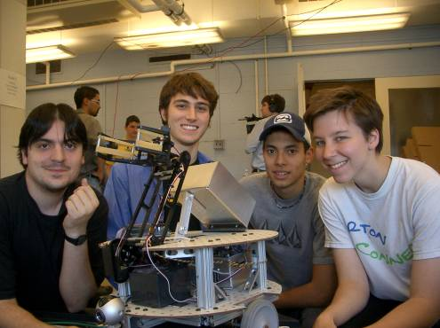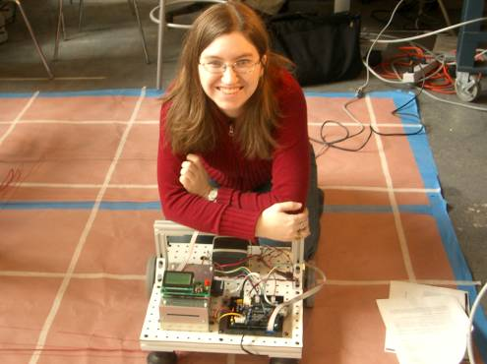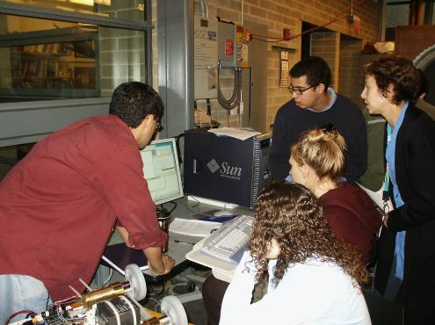
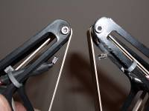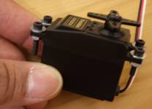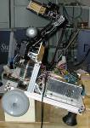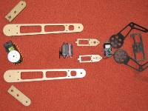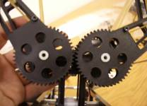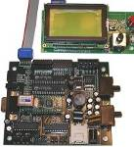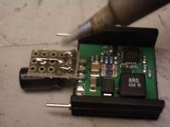

Course Objective

This project course continues the hands-on introduction to robotics begun in R:SS I. You will gain additional experience with the basic concepts in robotics, focusing on the mechanics and electronics principles behind building robots and on the classic algorithms, architectures, and theories behind controlling and programming robots. Topics include: motion planning, geometric reasoning, kinematics and dynamics, state estimation, tracking, map building, manipulation, human-robot interaction, fault diagnosis and embedded system development. You will build a robot in teams and implement the algorithms discussed in class in the context of the course challenge task: exploring an environment, gathering materials and assembling a structure.

Course Details

• Lectures: MW 11-12 (32-144) and occasional F 11-12 meetings; Labs: TR 2:30-4:30 (Gelb Lab)
• Credit: 12 Units (2-4-6), 12 EDPs. Fulfills EECS Departmental Lab credit or AUP.

