Style Guide for 16.401

Massachusetts Institute of Technology
Department of Aeronautics and Astronautics
Edition 2

Jennifer L. Craig

This document offers some guidelines for MIT writers who are writing and formatting documents and citing sources for deliverables required in communication-intensive courses. The guide covers some key points, but if you have further questions, please contact Jennifer Craig (jcraig@mit.edu or 617-452-3841.) or your professor.

Table of Contents

1.0 Document structure | 3
2.0 Executive summary | 5
3.0 Abstracts | 5
4.0 Grammar, punctuation, spelling, tone | 6
5.0 Citation styles | 7
6.0 List of references | 8
7.0 Conventions for using numbers | 9
8.0 Graphics | 10
9.0 Appendices | 10

1.0 Document Structure

1.1 Cover Sheet

Reports and proposals usually have cover sheets that contain the relevant information: author (s), date, context (course number or name, name of assignment).
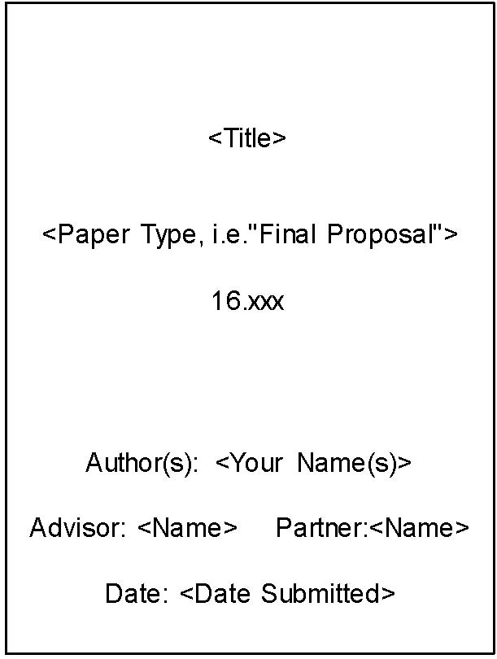
Figure 1: Cover Sheet Format

1.2 Sections and Subsections

Technical documents have sections and subsections to organize information. Give each section or subsection a brief, informative heading, and use a modest emphasis technique (underlining, italics, bolding or slightly larger font size) to help the reader locate the section.

1.3 Page Numbers

Technical documents have page numbers as navigational devices. PowerPoint slides have numbers. It doesn’t matter so much where you put them, but they must be there.

1.4 Table of Contents; List of Tables and Figures

Professional documents longer than 5 pages usually have a Table of Contents that allows a reader to find sections easily. In addition, professional documents also list tables and figures separately from the Table of Contents so that readers may have independent access to those graphics.

1.5 Spacing and Fonts

Technical reports and proposals are usually double spaced or space-and-a-half with conventional margins.
There are two styles re: indentation and spacing.
• If you indent your paragraphs, you do not have to put space between them or between the first paragraph and the heading.
• If you do not indent your paragraphs, then the convention is to put space between them and between the first line and the heading.
Technical documents generally are in a conventional font and use 12 pt font size. Sometimes a smaller font is acceptable but never smaller than 10.

1.6 Acronyms

Acronyms should be spelled out the first time they are used and the acronym included in parentheses that follow. (e.g. The Trade Analysis and Requirements Review (TARR) is scheduled for . . .) Some acronyms are so familiar that they are practically words themselves (USA, NASA), but most need to be written out the first time. Try not to begin a sentence with an acronym. Reduce the number of acronyms when possible.

1.8 Equations

Equations should be labeled at the right side of the page and centered on the page. For example, Equation 1 shows that given drag coefficient CD, air density ρ∞ , planform area S, and airspeed V, drag D can be computed using
(Eq. 1)
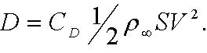
Equations can be either punctuated or not punctuated. Punctuating an equaption means adding a period when the equation is at the end of a sentence and a comma if the equation is in the middle of a sentence.

2.0 Executive Summary

An executive summary contains the key points of a document. It is written for a non-expert reader(s) and thus uses more general language than found in the main body of the document. It should be double-spaced on a separate page that usually precedes the table of contents. An executive summary is generally no more than one page long although longer proposals or reports may require longer executive summaries.
An executive summary is a compressed version of the entire proposal or report. It could be read in place of the proposal or report by a general reader who wanted to understand the project but didn’t have time to read the detailed version. Thus, an executive summary covers the significance of the work; summarizes the background and previous work in this area; describes the immediate project; may sketch out the experimental design; may summarize methods and materials; and ends with conclusions and discussions.

3.0 Informative Abstract
An informative abstract is single-spaced and 100-250 words. Abstracts are common on technical reports meant for experts while executive summaries are more common on documents meant for a wider audience. The abstract includes the following information: project, method, results, and conclusions. It does NOT include citations, acronyms, equations, abbreviations, background or discussions of future research. It stands alone; a reader should be able to grasp the key results of the entire project from reading the abstract. Since abstracts are written for an expert audience, they use more technical language. Abstracts are placed at the beginning of a document. Sometimes they precede the table of contents; at other times, they are placed just before the main text.

3.1 Other forms of abstracts
Descriptive abstracts are commonly written BEFORE the work is done. They might be appropriate for certain grant proposals or conference applications. They are not appropriate in a proposal or an experimental report.
Extended abstracts are sometimes requested for conference proceedings. They are considerably longer than an informative abstract---often several pages. They follow the basic outline of an informative abstract, but they can include equations and graphics. An extended abstract resembles a very compressed or succinct technical paper.

4.0 Grammar, Punctuation, Spelling, Style, and Tone
Standards of excellence for all technical documents include correct, complete sentences, proper punctuation, appropriate usage, and correct spelling. The Mayfield Handbook for Scientific and Technical Writing is a useful guide for grammar, punctuation and usage. As an MIT student, you are welcome to use their on-line resources:

http://web.mit.edu/course/21/21.guide/Demo/web/
Usually, early drafts of documents focus on technical content and organization, and it
is in the latter drafts that the writer polishes grammar, punctuation, and spelling and proofreads for correctness.
Technical documents have a distinct style and tone separate from grammar, punctuation and spelling. Because technical writing intends to present information as clearly and objectively as possible, the use of first person ( e.g. I, me) is not common in technical papers and oral presentations at technical meetings in this field. It is also not common to make the reader a participant. (e.g.. You can see that this project would be. . )
Sometimes, however, it is acceptable and advisable to use the word “we” in order to write a sentences that is more clear and concise.
Humor (or irony or sarcasm or wit( is/are not acceptable in technical writing. Although all these qualities can be entertaining, a writer can confuse a reader by including humor. Also, humor sometimes doesn’t easily translate across cultural lines. And lastly, humor in technical writing is out of place with the emphasis on clear, concise, organized and objective presentation of information.
Engineering writing and science writing is written frequently in the passive voice and has a slightly formal tone. This is acceptable. Engineers and scientists write about problems or solutions of significance, and it is their emphasis on clear, concise explanation that lends this serious tone. Yet, it sometimes takes writers a while to become comfortable writing in a professional voice without sounding stuffy. Reading a few published papers is helpful in finding your professional style.

5.0 Citation Styles

5.1 APA vs other styles
Citation styles are the way in which the writer acknowledges the intellectual work of others. In 16.401/6.401, faculty have chosen a parenthetical short text citation. The APA style is a good example. There ARE other citation styles, and other professors or an advisor may use one of them or you may see them in other books. If you want to submit work to a conference or journal, check the style requirements and the citation guidelines.
The general structure of the APA style is to place the last name of the author and

the year of publication separated by a comma and a space, in parentheses.

E.g. (Brown, 1998)
If there is more than one author, use all the last names the first time you cite the source.

E.g. (Brown, Meadows, Smith and Perrins, 1999)

In subsequent mentions, you can use the abbreviation et al in the text.

E.g. Brown et al (1999)

5.2 Types of Sources
There are two kinds of sources: those that any reader could retrieve from a library or an online source and those that are non-retrievable (conversations, e-mail, unpublished notes or writing). The retrievable source is cited in the text and listed in the “List of References” section at the end of the text; these citations follow specific guidelines.
For APA, your citations for retrievable sources are listed at the end of your

document and have four elements: author (s), date, title, and

publication information and page numbers.

E.g. Brown, L. (2006), Renovating your home on a budget. Cambridge, MA: Grace Publishing.

Please note that the writer lists only the sources that s/he cites in the report or proposal. Thus, you may read ten sources and cite five. Those five sources are the only citations in your list of references. The bibliographic style---where you list all the sources you read whether you cited them or not---is commonly reserved for books and then it is only done sometimes.

5.2.3 Non-retrievable Sources
Non-retrievable sources are those that are personal or undocumented. In APA style, you do not cite such information in the list of references. Instead, you list the initials and last name of the person being used as a source, the type of communication and the date of the communication. This kind of information is not as credible as peer-reviewed and professionally published information, but citing it shows your understanding of ethical procedure and contributes a measure of credibility to your work.

E.g. (L. Brown, personal communication, August 18, 2006)

5.2.4 Unpublished Material
Handling material that you believe is unpublished is tricky. The first step is to search library databases/journal databases to see if perhaps it has been published subsequently. If so, use that source. If not, then use the style for citing non-retrievable information.

6.0 List of References
Lists of references at the end of the document are organized differently according to style. The in-text, parenthetical citation points out the intellectual contribution of others, and the list of references at the end gives the bibliographic material that would allow another researcher to follow up on your research. Here, we show some examples of how the list of references is done. The List of References in APA style is always double spaced.

Here are a few examples of some sources you might commonly cite. For others, please use the Mayfield Handbook URL above.

• Documents available through the Web
Preston, R., (date of document if available) Reducing Induced Drag.
URL http://142.26.194.131/aerodynamics1/drag/page8.html,
(visited October 10, 2002).

• A book by several authors
Perelman, L., Paradis, J., and Barrett, E. (1998), The Mayfield Handbook of Scientific and Technical Writing, Mountainview, CA: Mayfield Publishing.

• Professional journal
Walker, R. E., Stone, A. R., and Shandor, M. (1963), Secondary Gas
Injection in a Conical Rocket Nozzle, AIAA Journal, Vol. 1, No. 2,
pp.334-338.

• Paper published at conference proceedings:
Paez-Borrallo, J.M., Perez-Alavarez, I.A., & Bello, S.Z. (1994). Adaptive filering in data communications with self improved error reference. In IEEE International Conference on Acoustics Speech and Signal Processing (pp. 65-68) . Adelaide, Australia: Institute of Electrical and Electronic Engineers.

• Unpublished paper presented at a meeting:

Lai, M., Chen, B., and Yuan, S. (1995, 12 December). Toward a new educational environment. Paper presented at the fourth International World Wide Web Conference in Boston, MA.

8.0 Graphics

Graphics are either tables or figures. Tables are columns and rows. All other graphics are figures (photo, sketch, graph, chart, etc).
Graphics are always labeled with a number and an informative title. Figures are labeled on the bottom. Tables are labeled at the top. If you borrow a graphic from another source, indicate that in small print in the title.
When you use a figure or table, place the figure or table after the place in which you refer to it in the text. In the text, refer to the graphic, give the number, and explain briefly what it is. A reader counts on the writer to interpret the data in the graphic.
Size the graphic to fit into the text. As seen in technical papers, almost all figures and tables can be reduced to less than a page without impairing readability. However, a full page graphic is acceptable if you really need all that space to display the information. It’s conventional to place very large or multi-page graphics and unrefined data sets in the appendices to allow readers access to that information without interrupting the flow of the text.
Use color judiciously. In technical graphics, color indicates information. It isn’t used decoratively.

7.0 Conventions for Using Numbers
In technical documents, use numeric figures for all quantifiable units of measure, no matter how small, be they nanometers or light-years. Also, use a figure when you abbreviate the measure. (Ex. 2m, 0.3 cm, 1.4 in) If two units of measure come together in a sentence, spell out one and use figures for the other. (Ex. Ten 4 cm sections of pipe were cut.) When using numerals, set decimal fractions of less than 1.0 with an initial zero (Ex. 0.05 cm). Don’t begin a sentence with a numeric figure. You can either spell it out or revise the sentence. Also, use consistent systems of measurements. Describe it in either inches or centimeters, but not both.

8.0 Appendix (or Appendices)
Appendices are placed at the end of the document. They contain material that the reader of the document may find very useful in using the report or proposal but that s/he doesn’t actually need in order to read the document. Examples of content placed in appendices include unrefined data, human subjects permission forms, materials lists, drawings or other large graphics, detailed calculations or theoretical development, sample interviews, and/or resumes.
Appendices would be divided into logical categories of information and labeled “Appendix A” or “Appendix B” and listed in the Table of Contents so that a reader could locate information.

